
Dear Parents/Guardians:

We have entered the home stretch as the month of June is upon us and what an amazing year it has been at Fox Creek School. We can’t believe time has gone by so fast and that we are nearing the end of the school year. Again, thank you to all the firefighters, companies and individuals who worked so hard to keep our town safe during the wildfire evacuation. It is great to be home safe and sound with school back in for students.

June does not slow down at Fox Creek School and thus we wanted to highlight some events that are happening in June.

For Elementary students, they can look forward to year-end activities and a modified Fun Track and Field day on June 23rd. For our Gr. 6 and Junior/Senior students, we have the year-end dance on June 15th.

The final exam schedule is listed on our school website, as well as other important year-end dates.

In addition to these activities, the end of the year brings report card time for students and thus, we wanted to communicate to all parents how we will be distributing report cards this year. As a result of all grades moving to an online report card and having all grades in the parent portal, parents can access final marks through this system. We will be mailing out a final report card the first week in July.

June is also a big month for our Grade 12 students as their journey at Fox Creek School has come to an end and thus, we celebrate their graduation. Grad 2023 will take place on June 24 in the school gymnasium with the ceremony occurring at 3 pm. In addition to the Grade 12s graduating, we will have our Kindergarten Graduation
on June 27 @ 7 pm in the school gym.

Finally, we want to thank everyone who supported our school this year. We will be planting a number of trees on June 15 with money we received from Trees Canada. Pembina Pipelines will also help us plant the new trees on June 15 and are providing hot dogs for K-12 students on June 23.

Thank you again for your continued support as we move together as an educational team; you, your child and the Fox Creek School staff.

Sincerely,

Fox Creek School Administration Team

Parent Newsletter
JUNE 2023

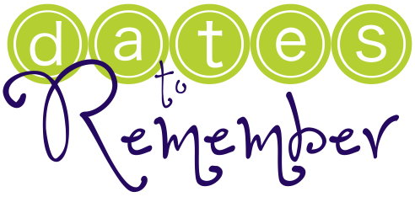



June 15 – School Council Meeting @ 7pm
June 18 – Father’s Day
June 24- Grade 12 Graduation Ceremony
June 23 – Elementary Fun Track Day
June 23-29 (Grade 7-9) Final Exams
June 27 – Kindergarten Graduation Ceremony @ 7pm (School Gym)
June 28 –Kindergarten Class/ Splash Park
June 29 – Elementary Assembly @ 1 pm
June 29 – Last Day for Students

School fees are now past due.
Log on to School Cash Online to find out the amount you owe the school. Access to extra-curricular activities may be removed if there are outstanding fees to be paid.
We strongly recommend the use of School Cash Online to pay your past due amounts.
Partial payments can be made if need be. We will still accept cash, cheques, interac, or credit cards at the counter. If you use a credit card at the counter a 2.5% fee will be added to the amount you owe.
Why Use School Cash Online?
Convenient - Make secure payments 24/7 from the comfort of your home
Easy To Use - Online shopping with various payment methods
Safe - Your child won’t be carrying cash or checks to and from school
Saves Time - Manage your school expenses and view payment history in one place.

BEING THE CALM
If there is anything that all parents have in common is an insatiable desire to protect our children. It is an instinct unlike no other. Just a quick scroll through the news or social media instills an unfathomable fear of impending risk to our children and with that fear is a deep knowing that there is literally nothing we would not do to protect them.

When frightening things happen in the world, or even in our community, we are often torn about what to say and how much information to share to reassure our children that they are safe. Honesty is ALWAYS best. Stick to the facts and what we know to be true. Consider the age and maturity level of the child. Not every child can handle all the details of every scary or stressful situation.
In 24 years of crisis and trauma work with families, the most common needs I hear children express:

Am I safe?
Can I trust the adults in my life?
When can things go back to normal?
How we discuss frightening situations with our children can impact their beliefs about the world we live in. Will we focus on fear and all the bad things that COULD happen? Or will we focus on the good people who are working at keeping the world safe? As the safe adults in our children’s lives, our message should be: scary things may happen in this world but together, as family, school, community, we are strong enough to handle it.
WHAT CAN WE DO TO CREATE CALM FOR OUR CHILDREN?
We can point out the good we see everyday, particularly amidst a crisis: look for the heroes and the helpers; look for kindness, bravery and courage.
We can remind our children that most people are good and kind and have no intention of hurting them.

- We can monitor the amount of negative news and social media we ingest as a family.
- We can take time to self-reflect about our own feelings and behaviors. We are the models for our children and they will follow our lead.
- We must ask ourselves: are we adding to the stress or are we creating calm?
- We can ensure that our words match our behaviors. Are we saying to our children that everything is okay and not worry, yet they watch us cry or act angry? If our children do hear our voice tremble or see tears, it's important we are comfortable with our emotions and concerns, then explain our feelings AND reassure them we love them and will support them always.
- We can be sure to keep the focus on our children’s feelings and not to make stressful situations about US.
- Most importantly, as parents, our children need to know that we are always available to them, check in with them often and answer their questions honestly and appropriately.

If you find your feelings of anxiety and fear do not go away, access professional and community resources.
Kid’s Help Phone www.kidshelpphone.ca/resources-around-me or call 1-800-668-6868, Mental Help Line 1-877-303-2642 or crisis support www.alberta.ca/individual-family-crisis.

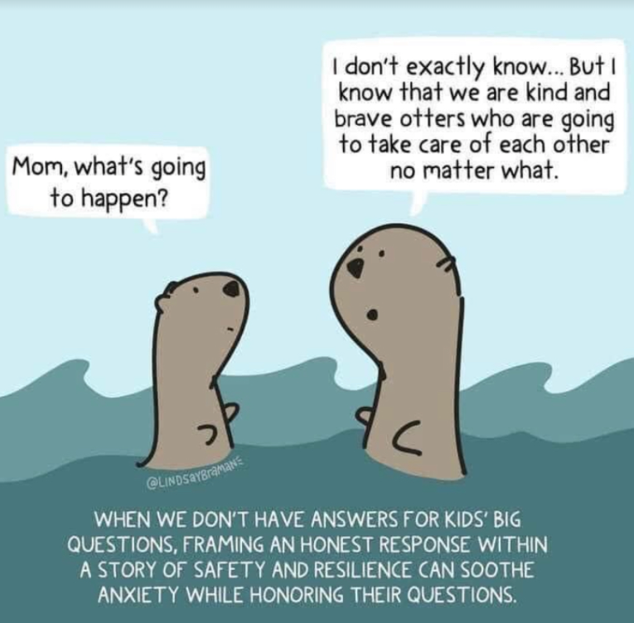

This article was submitted by Tammy Charko BA, BSW, and RSW. Tammy is Northern Gateway Public School’s Student Support Facilitator. She is a support for schools, students, parents and caregivers to encourage success in school. Tammy advocates for students and provides a link between the student and other supports within the community. Tammy has been a social worker for over 24 years and is a mother to 4 children.



Community Events






Fox Creek School Presents


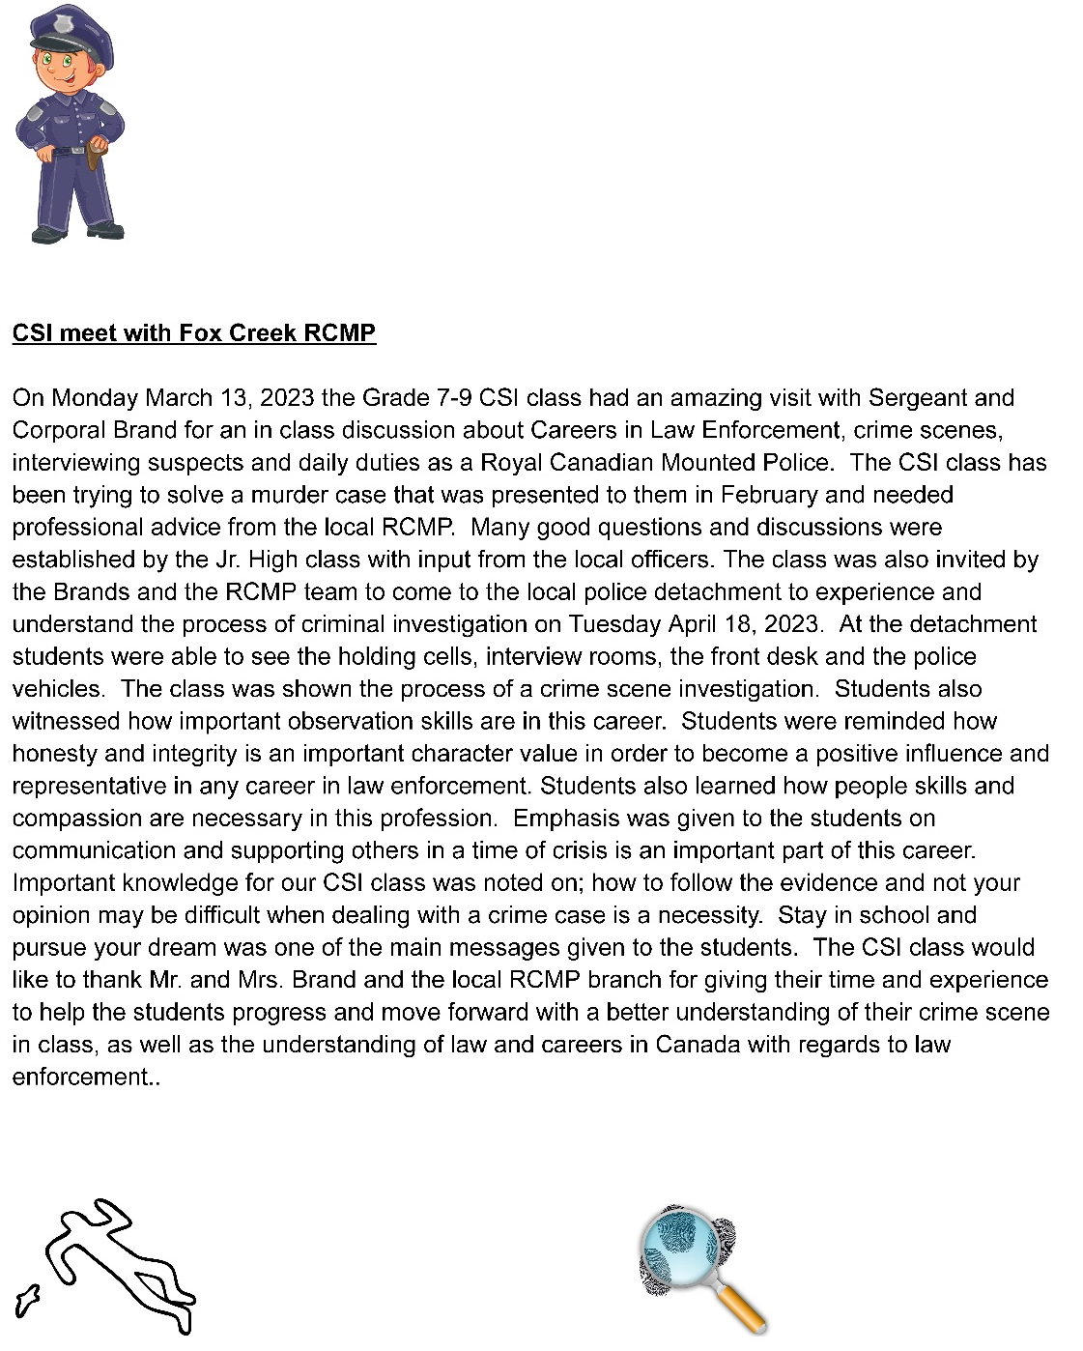


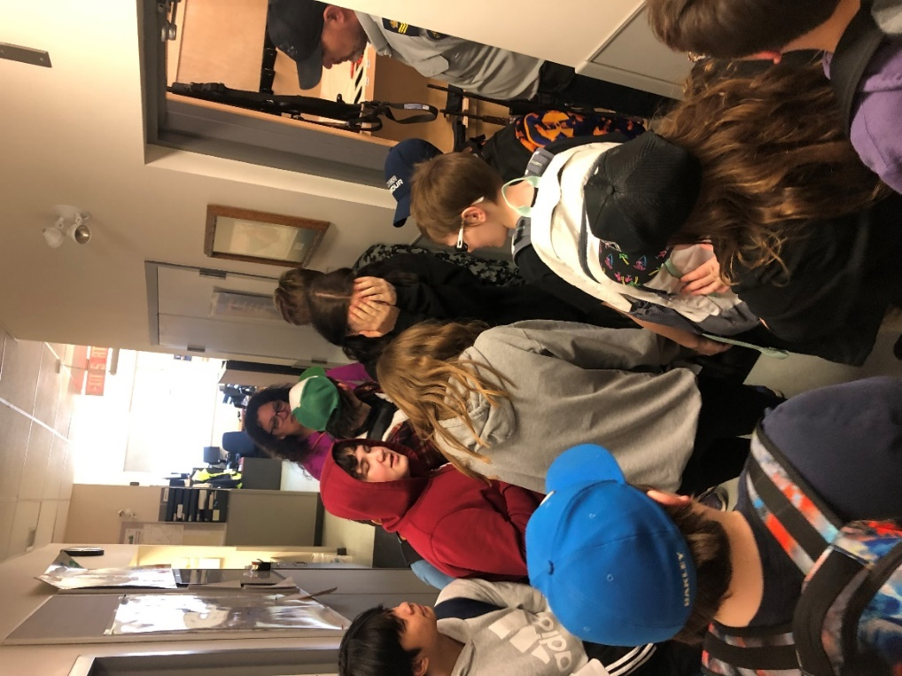
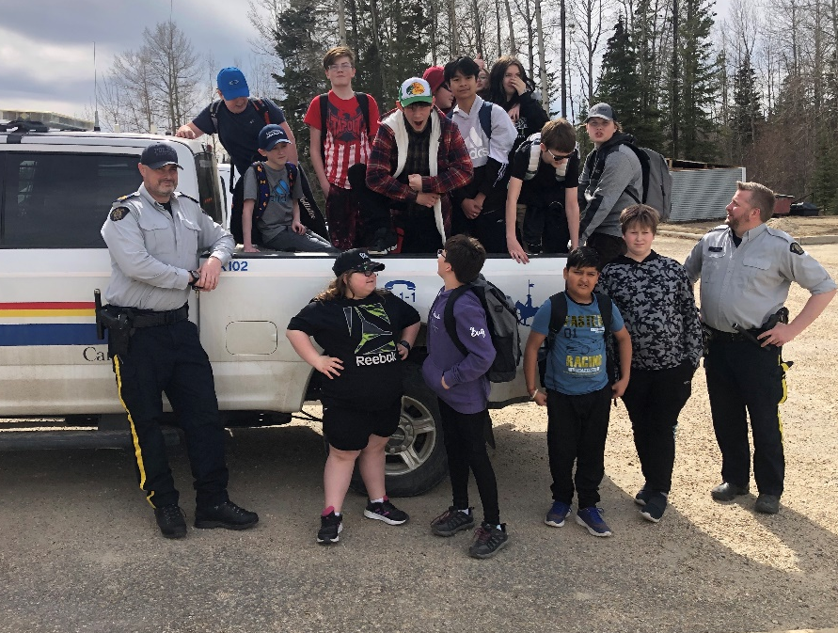

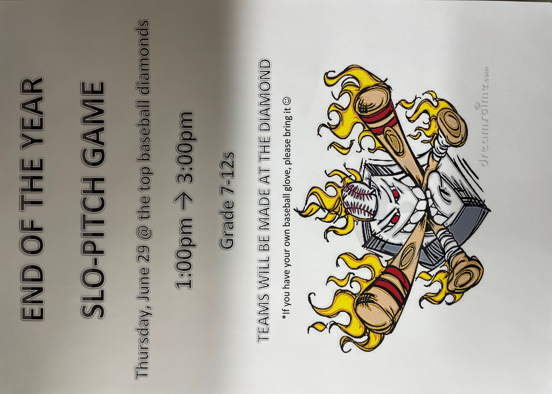
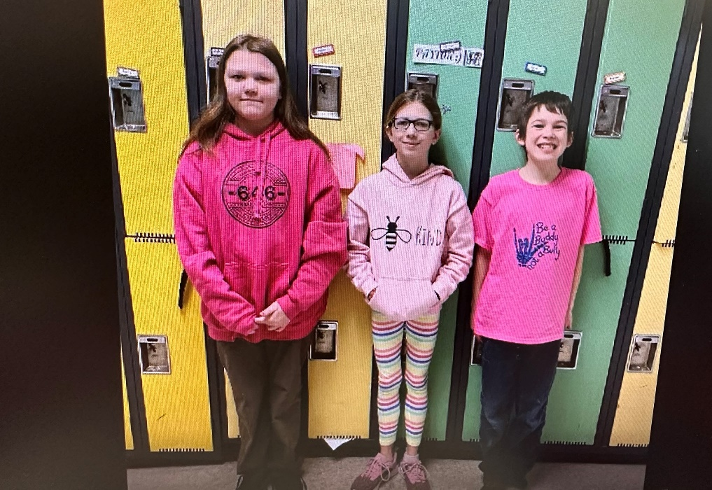
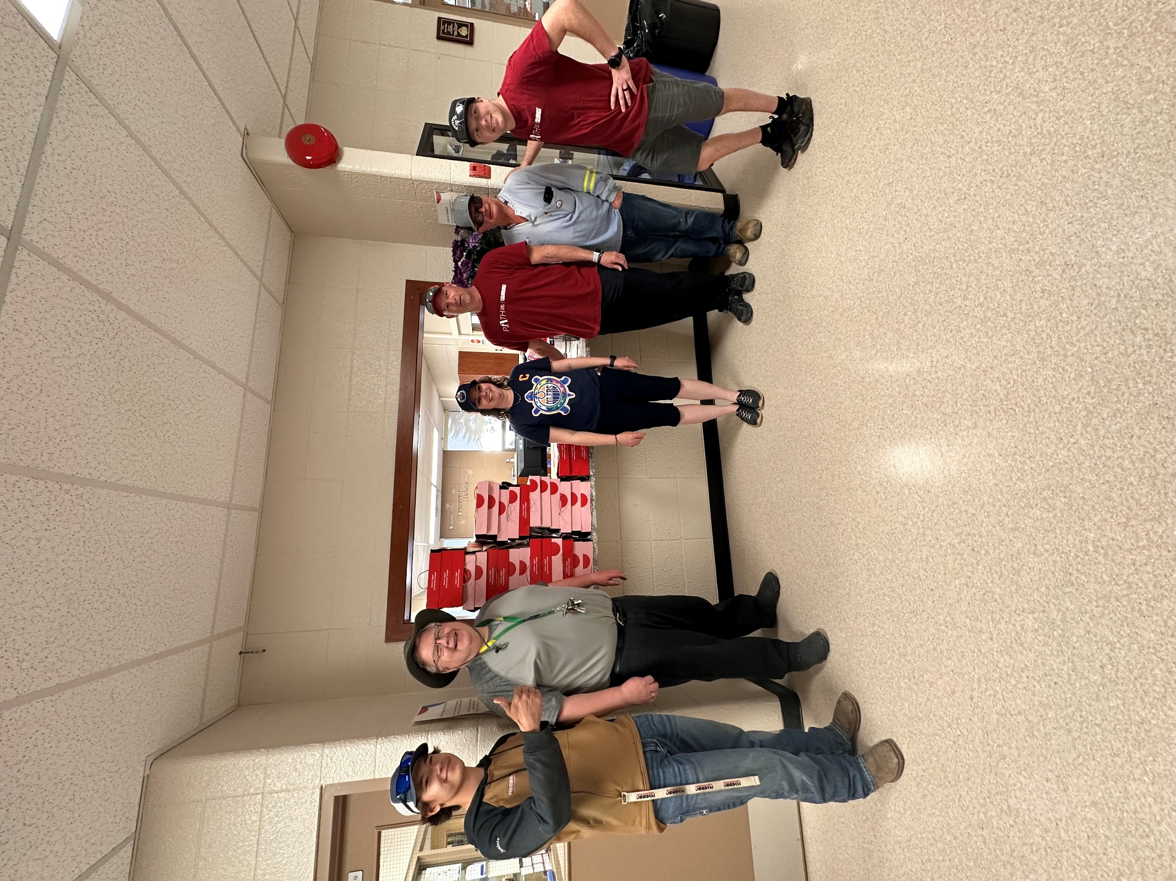
Thank You Pembina for bringing Tim Hortons Smile Cookies for the Entire School !!

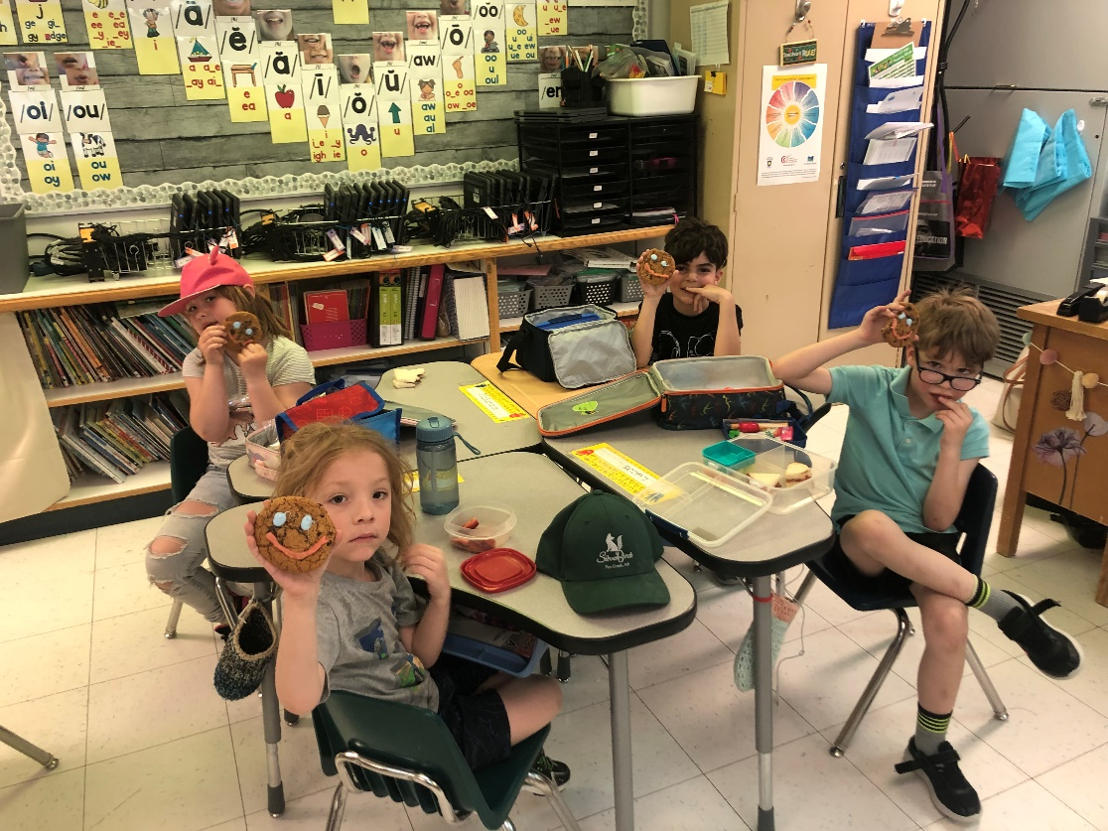

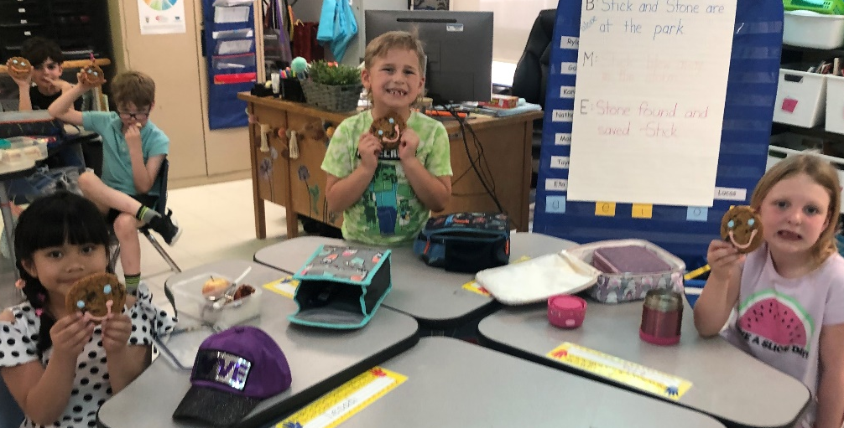
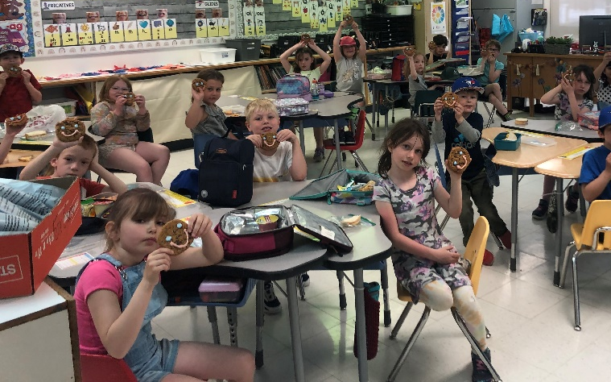

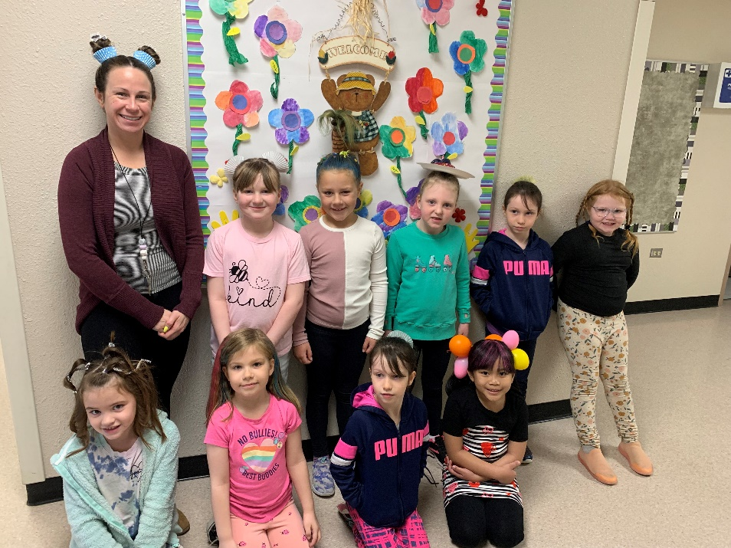
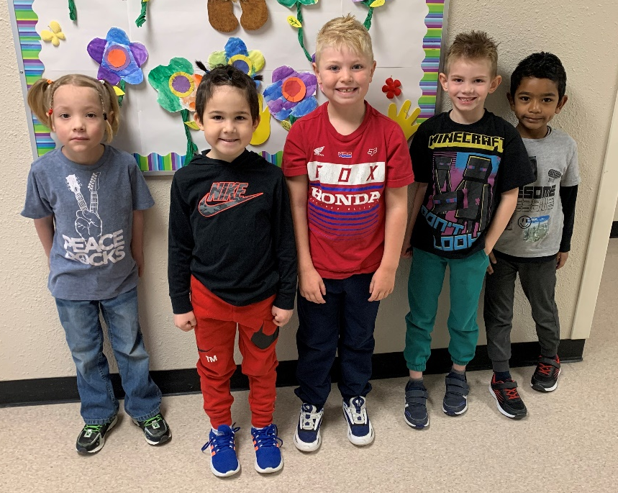
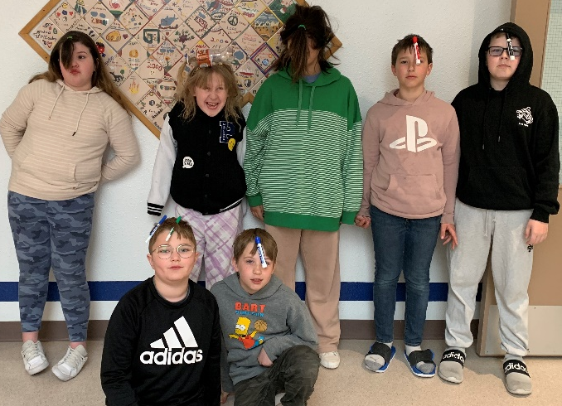
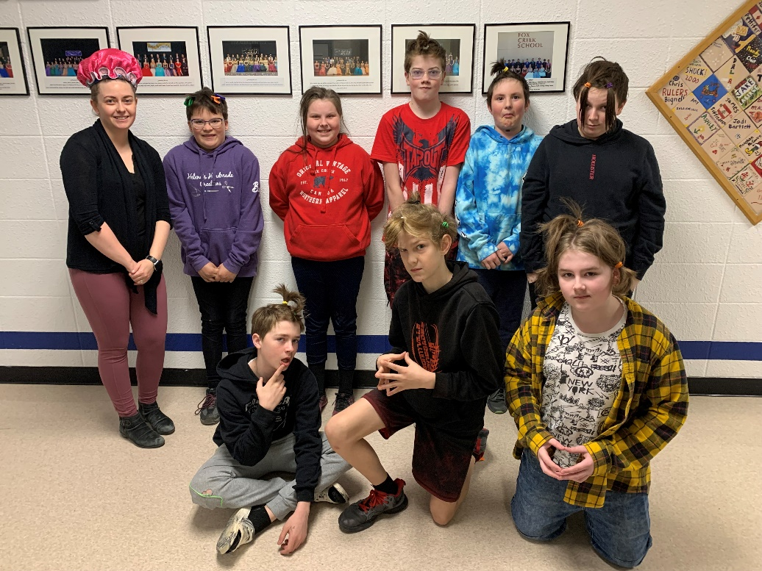
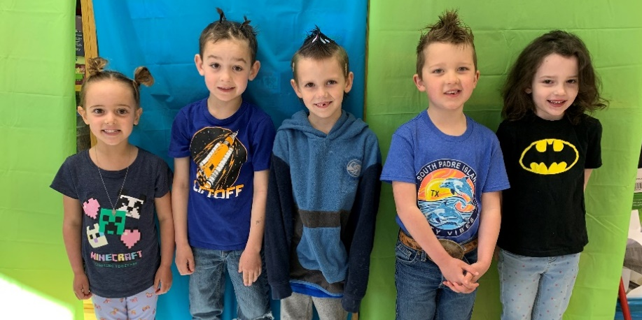


Gr
MONTHLY WINNERS

Winners of posters from School Council.
Gr.3 Jor-El Fernicol
Gr.4 Stewert Preete
Gr.5 Mason Smith-Mackenzie
Gr.6 lyanna Durias



Winners of $5 gift cards from Rexall for SPARKS (showing good citizenship and responsibility).

Gr.2 Natalie Guay
Gr.2 Irene Galliot
Gr.2 Kaylee Kozsan
Gr.6 Aubree Stevens

